Devotion for Saturday after the Third Sunday in Lent - Currency of the Kingdom - 5 March 2016, Anno Domini

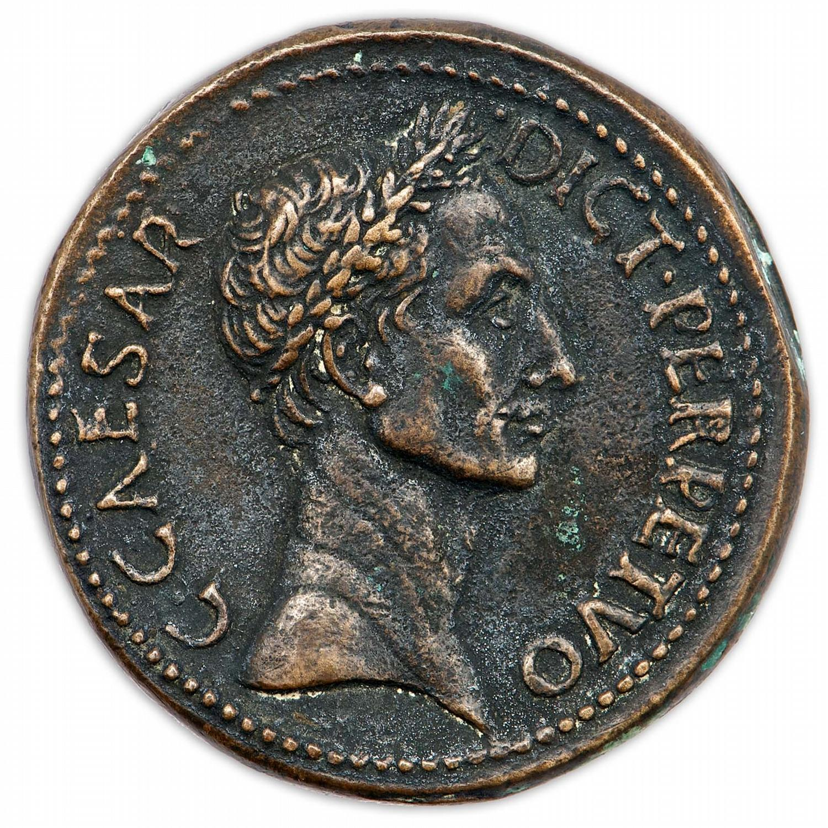

13 And they send unto him certain of the Pharisees and of the Herodians, to catch him in his words. 14 And when they were come, they say unto him, Master, we know that thou art true, and carest for no man: for thou regardest not the person of men, but teachest the way of God in truth: Is it lawful to give tribute to Caesar, or not? 15 Shall we give, or shall we not give? But he, knowing their hypocrisy, said unto them, Why tempt ye me? bring me a penny, that I may see it. 16 And they brought it. And he saith unto them, Whose is this image and superscription? And they said unto him, Caesar's. 17 And Jesus answering said unto them, Render to Caesar the things that are Caesar's, and to God the things that are God's. And they marvelled at him. (Mark 12:13-17)

The powers of the world are arrayed against the people of God, no less now than at the end when all of the world powers, in alliance with Satan, shall gather for battle against the Remnant of God's people: And (Satan and His forces) shall go out to deceive the nations which are in the four quarters of the earth, Gog and Magog, to gather them together to battle: the number of whom is as the SAND OF THE SEA. And they went up on the breadth of the earth, and compassed the CAMP OF THE SAINTS about, and the beloved city: and fire came down from God out of heaven, and devoured them. (Rev 20:8-9) A Camp is very small compared to the world; yet, in Christ, it is victorious over it.

We see in today's text how the powers of the religious world are allied with those of the secular world against Christ. We read in the previous chapter (Mark 11) how Jesus cleansed the Temple. At that point, the religious leaders began to plan a means of destroying Jesus. They question His authority, but dare not question His power. And they come again to Jerusalem: and as he was walking in the temple, there come to him the chief priests, and the scribes, and the elders, And say unto him, By what authority doest thou these things? and who gave thee this authority to do these things? (Mark 11:27-28) As in all cases, our Lord turned the tables on these deviant rascals. Now they send emissaries of mixed allegiance - those of the Pharisees (religious) accompanied by representatives of the Herodians (those who live off the secular power and owe fealty thereto). Mind you, the Jewish leaders and those who supported Rome's occupation of Judaea were not normally allies; but BOTH see in Jesus a common enemy of far greater danger to their interests and power than either the Roman yoke or the religious despots.

Did these Pharisees and Herodians seek truth in sincerity, or did they come with ulterior motive? They were not truth seekers for they came " to catch him in his words." I am amazed that these cunning foxes continually made the same mistake of trying to catch Jesus in His words - for each time, they were vanquished and humiliated. The present occasion is no different. These fools spent much time deliberating on some question that would surely be the final snare in which they would catch Jesus in His words. "And when they were come, they say unto him, Master, we know that thou art true, and carest for no man: for thou regardest not the person of men, but teachest the way of God in truth: Is it lawful to give tribute to Caesar, or not?" In their words is an example of how truth can be turned on its head by wicked men. They seem to admit a knowledge that Jesus spoke truly always without deference to the dignity of class or position. The opinions of men were of no consequence to Jesus - He only spoke the truth and will of His Father in Heaven.

Ensconced in their question was the ultimate in hypocrisy: Is it lawful to give tribute to Caesar, or not? Even as they asked this question, they are in possession of coinage issued by Caesar. If you will use the protection and commercial advantages of Rome, you must be willing to pay tribute to the power you consider sovereign and from whom you gain the privilege of the medium of exchange. These men had already compromised the principle for which they were suggesting the question. If it is lawful to use Caesar's currency, it must also be lawful to pay tribute for that privilege. "Shall we give, or shall we not give?" Note the malicious intent hidden in this question: If Jesus answers frankly that we should pay tribute to Caesar, He will be ascribing power to an ungodly government. If He answers that we should not pay tribute to Caesar, He will provoke the wrath of the Roman power against Him. Either way, the malicious intent of the questioners will be achieved.

So how shall Jesus answer these men and, at the same time, avoid the trap they have skillfully set for Him? But he, knowing their hypocrisy, said unto them, Why tempt ye me? bring me a penny, that I may see it. Matthew's Gospel gives a more detailed response by Jesus: Shew me the tribute money. (Matt 22:19) In this latter request, Jesus is calling for the very coinage with which tribute is paid. If these men did not honor Caesar by using his coinage, they would not have had it in their possession - but they DID! In both Gospels, Jesus calls their hand in "tempting Him" showing that He saw the wickedness concealed in their hearts. And they brought it.

And he saith unto them, Whose is this image and superscription? Jesus is asking, "Whose money have you brought me?" The coin - a denarius - was stamped with the likeness of Caesar, and the superscription provided the name of the current Caesar - Tiberius! This showed that the coin was issued, and its value guaranteed, by the authority of Caesar of Rome! The Christian, too, is stamped with a likeness of Christ and His own superscription "Lord of Lord and King of Kings." We are the currency of the Kingdom of Heaven, but it is Caesar's that is the currency of the world.

The question Jesus put to the detractors was simple, direct, and complete! Whose is this image and superscription? They asked Jesus a hypothetical questions with more than one answer possible. But Jesus asked them a question with only ONE possible answer, and that answer would settle the issue! "And they said unto him, Caesar's." So, the coin was issued by authority of Caesar, was it? If the medium of exchange is Caesar's, should not the medium by which tribute is paid be by that same authority? And Jesus answering said unto them, Render to Caesar the things that are Caesar's, and to God the things that are God's. This was a perfect rebuttal that closed off further discussion of the matter and placed the inquirers in the bad light that their intentions demanded. They were flabbergasted and amazed at the trap that had closed on their own heads and not that of Jesus: And they marvelled at him. This answer of course comported with a maxim espoused by the Pharisees themselves: "He whose coin is current is king in the land."

The point is clear that we owe tribute to the secular power as a minister of God to protect and provide an atmosphere for trade and commerce. But the greater point in the response of our Lord is our duties and obligations to God. What do we, as Christians with His image and superscription, owe to God? After all, we are stamped with His image, are we not? And God said, Let us make man in our image, after our likeness. (Gen 1:26) It is true God created man in His own image unmarred by sin; and man later sinned and fell from grace. However, man still possesses in a marred form that image of God. American coins in circulation were stamped at the mint with an unblemished quality, but after many years in circulation, one can still read the words, "In God we Trust" even if not as crisp and clear as a freshly minted coin. As Christians, our lives must bear out that testimony - "In God we TRUST." Though the meager penny is left on the road to be trampled under-foot of men and automobiles, though it survive the burning home, though it be washed up from the ocean on lonely beaches, though it pass through many scheming hands - it is, at last, still a penny and coin of the realm with the superscription - "In GOD we TRUST." So must Christians bear up in this world.

When visiting our churches in the beautiful Philippine Islands, I saw one of their notes of currency - I believe a five peso note. It was inscribed with the words - "The Filipino is worth dying for." I was deeply impressed by that principle so clearly stated; for the Filipino is surely worth dying for, and so is every other nation, kindred, and tongue, for Jesus did the dying in redemption of our sins for us. Our Duty to God?

- We are sealed with the seal of God. "I beseech you therefore, brethren, by the mercies of God, that ye present your bodies a living sacrifice, holy, acceptable unto God, which is your reasonable service." Romans 12:1 (KJV)
- We are not of this world. "Be not conformed to this world: but be ye transformed by the renewing of your mind, that ye may prove what is that good, and acceptable, and perfect, will of God."Romans 12:2 (KJV)
- Our Time Belongs to God - not simply a tithe of that time, but all of it, since God has given us all of our days.
- All of our knowledge and learning belongs to God, for He is our teacher of good and righteous things.
- All of our material possessions and worth both come from God and are owed to God. We are merely stewards of that wealth.
- Our influence and means also belong to God. We must labor for God in our industry, in our political actions, in our families, our churches, and our communities.

All of these things belong to God. If I own my home, I must own everything contained in that home. The earth is the LORD'S, and the fulness thereof; the world, and they that dwell therein. For he hath founded it upon the seas, and established it upon the floods. (Psalm 24:1-2)

You, Christian, belong to the Lord. Pay TRIBUTE in kind. He has bought you with a grievous price.

